**GITHUB ACCOUNT REGISTRATION**

1. Open www.github.com and select the signup.

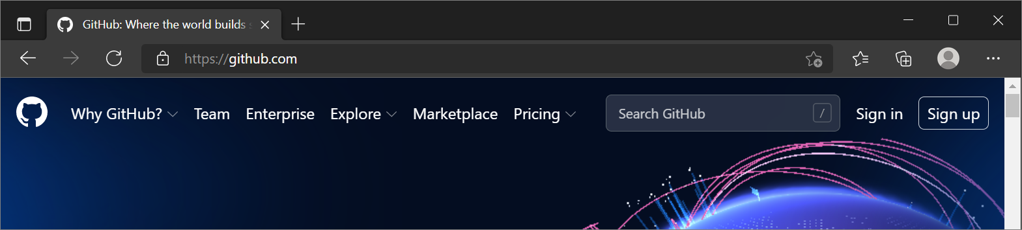

1. Enter your Email Address.

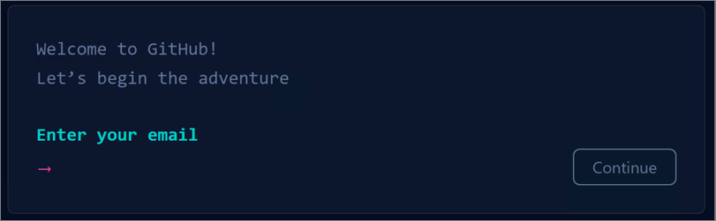

1. 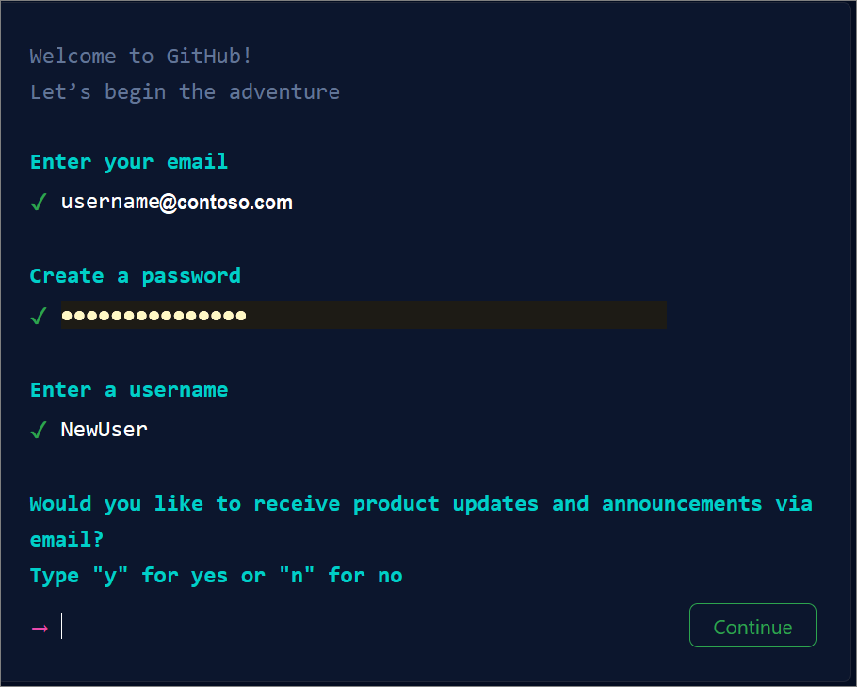Create your password for github, also add a user name and choose to receive updates or not on your email.
2. Verify account by solving puzzle.
3. After verify account click on the button “Create Account”.
4. Next, Github sends you a code via your email. Enter that code in the “Enter Code” dialogue.

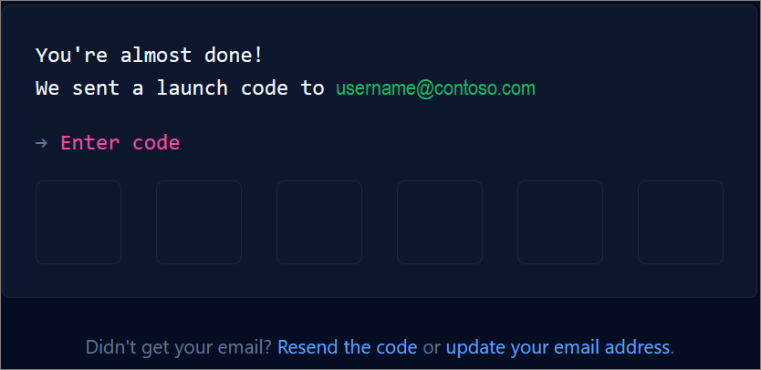

1. Github asks you to select how many members and what your profession is.

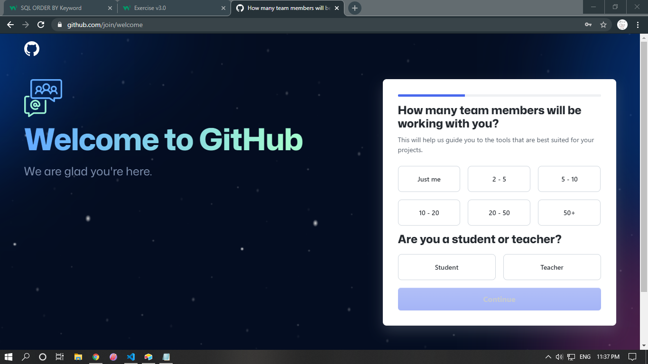

1. What specific you interested in using?

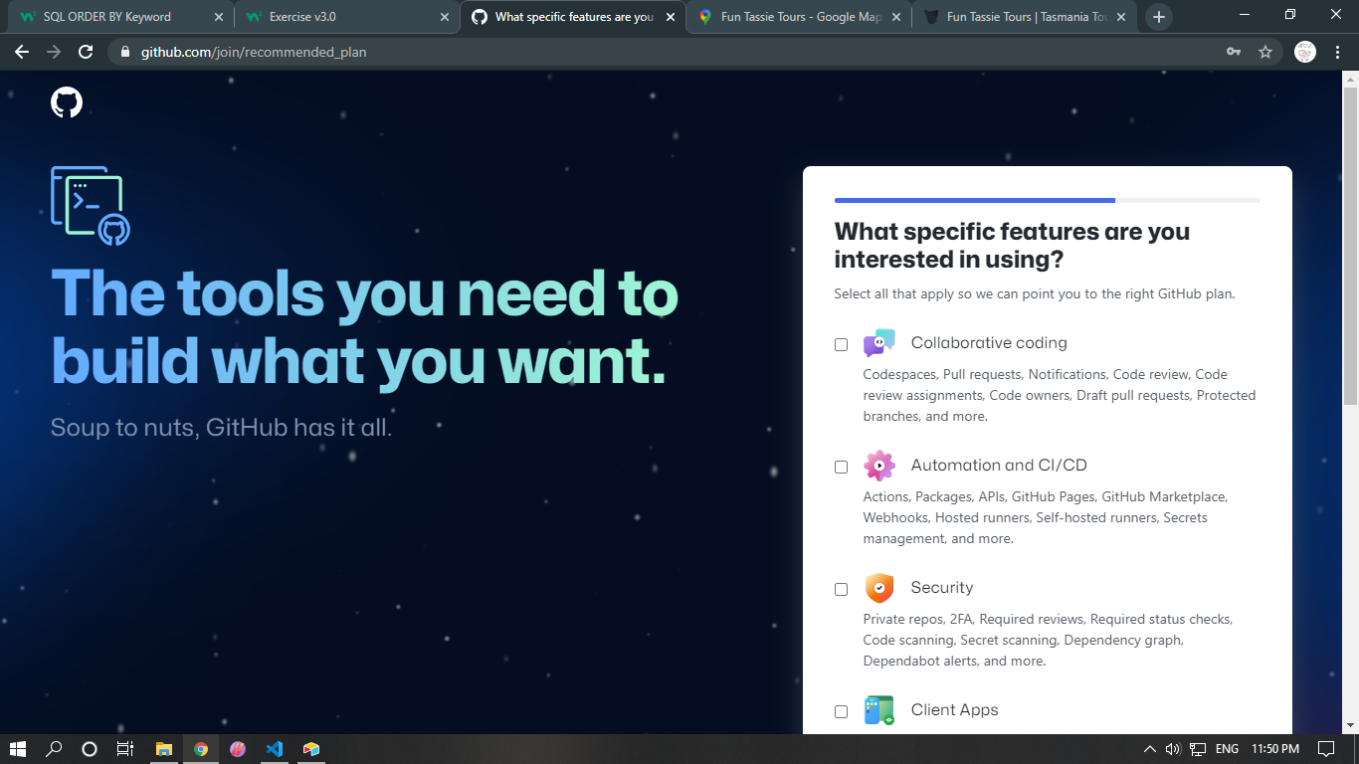

1. In the last Github asks you for account type Free or Premium?

**Account Created and Finalized**

